Elijah Saavedra

CST-350

Activity 5

**Activity 5 Part1:**

**Screenshot 1: Here is a screenshot showing all the products after going to the default route**

**Screenshot 2: Search for a product, in this case it was soup**

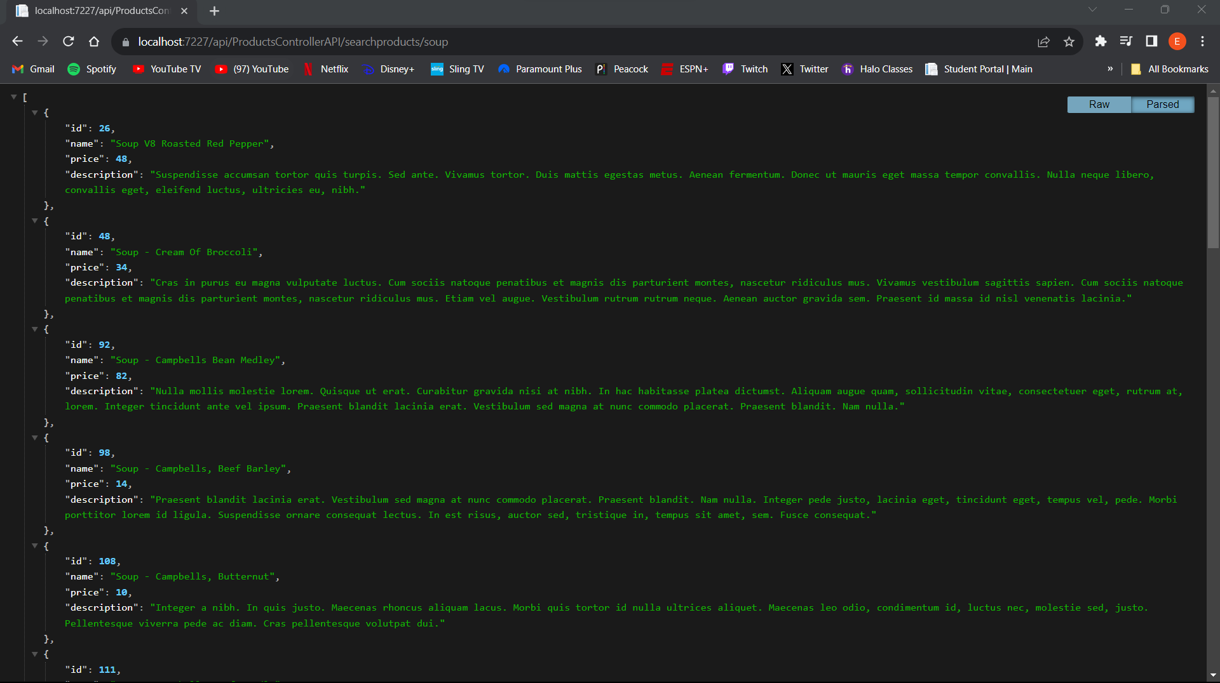

**Screenshot 3: Showing just one product**

**Screenshot 4: Using PostMan and getting the information of all the products**

**Screenshot 5: Using PostMan to search for a product, in this case it’s lamb**

**Screenshot 6: Using PostMan to get just one product**

**Screenshot 7: Using PostMan to perform a Put command to change an item**

In this lesson, key concepts related to building a RESTful API using ASP.NET Core were demonstrated. These concepts included defining API routes using attributes on controller actions, using HTTP verbs (GET, POST, PUT, DELETE) to perform CRUD operations, handling parameterized routes for dynamic data retrieval, and managing API responses with the ActionResult class. We also used PostMan so that we can test the REST APIs that we created.

**Activity 2 Part 2:**

**Screenshot 1: Using the new DTO to show short description and Tax for one item**

**Screenshot 2: Showing all the products using the new DTO Model class, seeing the short description and tax**

**Screenshot 3: Using the search method to find a product and seeing the new DTO properties**

**Screenshot 4: Using the Process Edit returns for the entire list and return with the DTO properties**

In this lesson, we learned Data Transfer Object (DTO) in which we were able to get two new properties, short description and tax. After creating the new ProductsModelDTO, we were able to change the methods so that they can access this new model in order to obtain the new properties, so when we ran the application, we can see all the information of the product. This is important to learn as when we want to create applications with sensitive information, we know what properties to withhold and get.